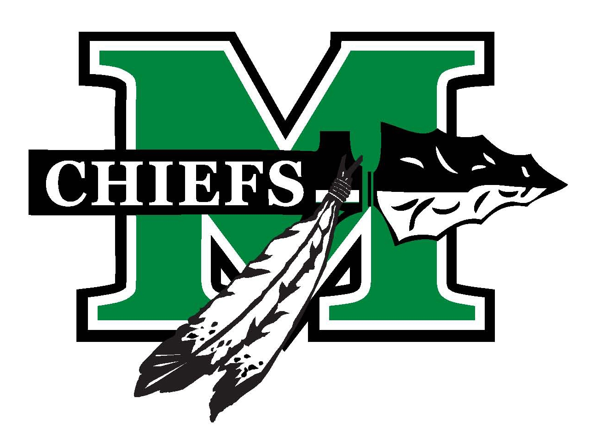

McIntosh Football/Competition Cheerleaders
---------------Sponsorship Program--------------
Silver Level: $50-$100
- Your company name listed in the host competition program.
- Your company name listed with our other sponsors on the MHS cheerleading website.
Gold Level: $200
- All of the above AND your company name on a banner which will be hung at the football stadium, on our homecoming float and in the school gym.

Platinum Level: $400
- All of the above Plus your company logo on all banners.
- Your company logo on the back of the cheerleaders t-shirts.
- Your company will be included in the shout outs at host competition.
- Sponsor spotlight on MHS Facebook page.

This is a tax-deductible contribution. Tax Id #46-4881399. (Please keep this portion for your records.)

Any Questions:
Booster Vice President – Kim Frandsen (404) 409-0752
Thank you for your support!

Deadline: July 13, 2017
*Deadline requirement is for submission requirements to printers/vendors

Please return this section with a check made payable to:

MHS Football/Competition Cheerleaders Booster Club
(MHSFCCBC)

C/O Kim Frandsen
102 Sandtrap Ridge
Peachtree City, GA 30269

Business Name _______________________________________________

Sponsor Level ________________

Contact Person at your Business _________________________________

Business Phone ______________________________

Cell Phone ______________________________

Business Address _____________________________________________

Website ______________________________________________________

E-mail address_______________________________________________________

Please email logo in JPEG or vector file to Kimfrandsen@live.com

MHS Cheerleader point of contact: ____________________

GO CHIEFS!!!

McIntosh Football/Competition Cheerleaders Booster Club
2017 Sponsorship Program

1994, 1998, 2013, and 2016 Girls State Championship
2014 and 2015 State Champion Runner Up Coed Division

Dear Business Owner/Manager:

I would like to introduce myself. I am _________________and proud to be a member of McIntosh High School Athletics Football/Competition Cheerleading Team. Our Varsity and JV squads cheer at all MHS football games and compete against other Georgia high schools in our Region and across state.

Our Booster Club relies on support not only from parents but also from members of the community, like you, to help us achieve our goals each year. In years past, our sponsors were instrumental in our ability to purchase new mats and a permanent run through for the use of all the athletic teams and for other school related functions and clubs. Your valuable support also contributes in funding items such as new uniforms, warm ups, and coaching fees, items MHS and the Board of Education do not fund. We also offer scholarship money totaling $1,000 per year to graduating seniors. Your support is beneficial to our program.

I have attached the information on the Sponsorship Program for our Football/Competition Cheer Teams. Please consider supporting our Booster Club by participating in one of our Sponsor Levels. Your name or your company’s name will be visible at football games, the school gym, as well as the cheer competition that we host.

Thank you,

McIntosh Football and Competition Cheerleaders

